**1. Exercise :** *3*  **2. Date :** *20th October, 2020*

**3. Title :** Fundamentals of Projections – Orthographic projection of points and lines.

**4. Aim :** To draw the orthographic projection of points in various quadrants; straight lines in first quadrant inclined to only one plane, and practice free-hand sketching.

**5. Software used :** *AutoDesk AutoCAD 2021.*

**6. Introduction :**

**i. About Orthographic projection:**

*Orthographic Projection shows the object with a top view, a front view and a side view. These three views are ‘projected’ and aligned with each other. In Orthographic Projection, lines are either horizontal or vertical and in Orthographic Projection, the views are mostly horizontal or vertical in relation to each other. It’s this alignment (projection) that makes the drawing easy to read.*

**ii. Projection of points and lines:**

***POINTS =>*** *There are basically nine type of projections of point is space :*

*1) In FIRST Quadrant 🡪 (Above H.P., In front of V.P.)*

*2) In SECOND Quadrant 🡪 (Above H.P., Behind V.P.)*

*3) In THIRD Quadrant 🡪 (Below H.P., Behind V.P.)*

*4) In FOURTH Quadrant 🡪 (Below H.P., In front of V.P.)*

*5) In PLANE 🡪 (On V.P., Above H.P.)*

*6) In PLANE 🡪 (On H.P., Behind V.P.)*

*7) In PLANE 🡪 (On V.P., Below H.P.)*

*8) In PLANE 🡪 (On H.P. In front of V.P.)*

*9) In PLANE 🡪 (On both H.P. & V.P.)*

***LINE =>***

*1) A straight line is the shortest distance between two points.*

*2) Top views of two end points of a straight line, when joined; give the*

*top view of the straight line.*

*3) Front views of the two end points of a straight line, when joined;*

*Give the front view of the straight line.*

*4) Both the above projections are straight lines.*

**7. Procedure** (for problem solving):

**7.1** Question Outline : *To understand the Fundamentals of Projections.*

**7.2** Object : *Projection of points, Straight lines inclined to one plane, etc.*

**7.3** Conditions (if any) : *All dimensions should be in millimeters (mm).*

**7.4** Scales Taken :*(10mm ; 1m) & (10mm ; 1ft).*

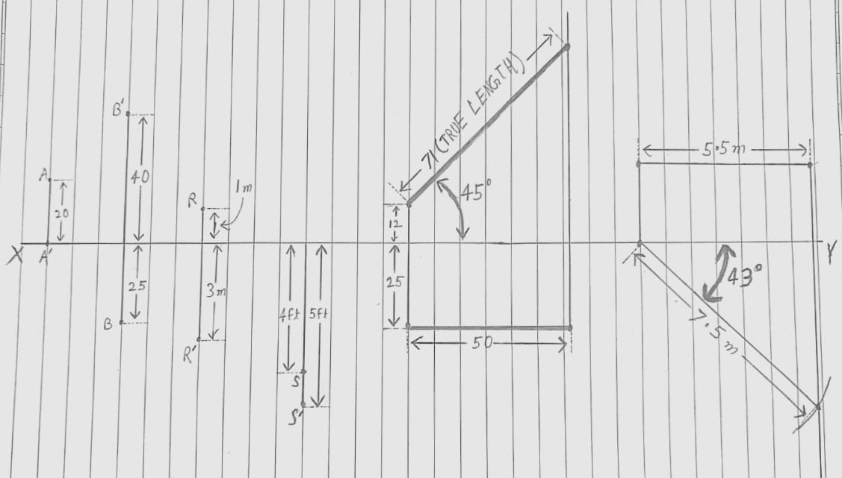

**Fig. Free hand sketch of the solution to question**

**7.5** Drawing Procedure :

**Step 1. *Setting up the workspace :-***

*i. Set the units & precision we are going to work with using “UNITS”*

*command, here we will keep precision to be 2 unit places (0) & unit*

*as millimeter (mm).*

*ii. Then, set the workable area using “LIMITS” command to area of*

*(297mm) (210mm) by specifying origin or lower left corner as (0,0)*

*& upper right corner as (297,210).*

*iii. Finally, use the command “ZOOM” with “all” attribute to expand*

*the work area to entire screen.*

*iv. Use Command “DDPTYPE” to set point type and size. Select* 

*and set size to 5.*

*v. Use Command “LINE” to draw a line of 330 units horizontally. Label*

*it as XY using the commands “STYLE” & “TEXT”.*

**Step 2.** ***Projection of point A :-***

*i. Use Command “LINE” to draw a line of 20 units vertically upwards.*

*ii. Use the command “POINT” to mark the projections of point A.*

*iii. Use the command “TEXT” to label the projection points as A and A’*

*for Top View (TV) and Front View (FV) respectively.*

**Step 3.** ***Projection of point B :-***

*i.**Since, point B lies in 1st quadrant, the FV projection will be drawn*

*above base line and the TV projection will be drawn below base*

*line.*

*ii. Use Command “LINE” to draw a line of 40 units vertically upwards*

*and 25 units vertically downwards*

*iii. Use the command “POINT” to mark the projections of point B.*

*iv. Use the command “TEXT” to label the projection points as B and B’*

*for TV and FV respectively.*

**Step 4.** ***Projection of point R :-***

*i. Since, point R lies in 3rd quadrant, the FV projection will be drawn*

*below base line and the TV projection will be drawn above base*

*line.*

*ii. Use Command “LINE” to draw a line of 10 units vertically upwards*

*and 30 units vertically downwards.*

*iii. Use the command “POINT” to mark the projections of point R.*

*iv. Use the command “TEXT” to label the projection points as R and R’*

*for TV and FV respectively.*

**Step 5.** ***Projection of point S :-***

*i. Since, point S lies in 4th quadrant, the FV projection will be drawn*

*below base line and the TV projection will be drawn below base line*

*overlapping with FV.*

*ii. Use Command “LINE” to draw a line of 50 units vertically downwards.*

*From the same point on base line, draw another line of 40 units*

*vertically downwards.*

*iii. Use the commands “POINT” & “TEXT” to mark and label both lines’*

*ends away from baseline as S for closer point and S’ for farther point.*

**Step 6.** ***Projection of Straight lines inclined to only one plane (Part-1) :-***

*i. Use Command “LINE” to draw a line of 12 units vertically upwards*

*and 25 units vertically downwards.*

*ii. From the end point of line of 25 units, draw a line of 50 units*

*horizontally. From its end point draw a vertically upward line of 100*

*units.*

*iii. From the end point of line of 12 units, draw a line with angle 45*

*degree to axis by using the command “LINE” with “specific rotation”*

*to cut the vertical line.*

*iv. This slant line is the required line.*

**Step 7.** ***Projection of Straight lines inclined to only one plane (Part-2) :-***

*i. Use Command “LINE” to draw a line of 25 units vertically upwards.*

*From the endpoint draw a line 55 units horizontally. From its*

*endpoint draw a line 100 units vertically downwards.*

*ii. From the starting point use the command “ARC” to cut an arc on the*

*vertically downward line with a radius of 75 units. Join the starting*

*point with intersection point.*

*iii. Use the command “DIMANGULAR” to measure the angle between*

*the slant line and axis. This angle is the required angle.*

**Step 8. *Annotations :-***

*i. Using the command “DIM” and its appropriate attributes to mark*

*all the dimensions taken in the experiment.*

*ii. Use the command “TEXTEDIT” to mark all the correct dimensions*

*according to the scale****.***

**8. Commands Used :**

|  |  |  |
| --- | --- | --- |
| *Sr. No.* | *Command* | *Use* |
| *1.* | *UNITS* | *Used to set unit type & precision.* |
| *2.* | *LIMITS* | *Define the workspace & give its boundary.* |
| *3.* | *ZOOM* | *Expand/Contract the work area to visible screen.* |
| *4.* | *LINE* | *Used to draw line.* |
| *5.* | *ARC* | *Used to draw an arc.* |
| *6.* | *STYLE* | *Helps to set font style, height & width.* |
| *7.* | *TEXT* | *Used to write a text.* |
| *8.* | *POINT* | *Used to mark a point.* |
| *9.* | *TRIM* | *Used to remove/erase any undesired line.* |
| *10.* | *DIM* | *Used to write the dimensions of the object.* |

**9. Result :-**

*Thus, by the use of AutoCAD 2021 we are able to draw the following*

*objects ;*

*i. Projection of Points.*

*ii. Projection of Lines.*

*With proper dimensions & measurements.*

|  |  |  |  |
| --- | --- | --- | --- |
| **Faculty Name** |  | **Date of Submission** |  |
| **Signature** |  | **Marks** |  |